
WEEK-8
AIM: Write a program for routing to different pages using react router.

DESCRIPTION: This program demonstrates how to implement navigation between multiple pages in a React application using React Router. It creates different components for each page and uses BrowserRouter, Routes, and Route to define paths and render the corresponding components. The program helps learners understand client-side routing, dynamic navigation, and building multi-page React applications without reloading the browser.

PROGRAM:

(App.jsx)
import React from "react";
import { BrowserRouter as Router, Routes, Route, Link } from "react-router-dom"; function Home() {
return <h2>Home Page</h2>;
}
function About() {
return <h2>About Page</h2>;
}
function AppRouter()
{
return (
<Router>
<nav>
<Link to="/">Home</Link> | <Link to="/about">About</Link>
</nav>
<Routes>
<Route path="/" element={<Home />} />
<Route path="/about" element={<About />} />
</Routes>
</Router>
);
}
export default AppRouter;

(Main.jsx)
import { StrictMode } from 'react'
import { createRoot } from 'react-dom/client' import './index.css'
import App from './App.jsx'

createRoot(document.getElementById('root')).render(
<StrictMode>
<App />
</StrictMode>,
)

Index.html)
<!doctype html>
<html lang="en">
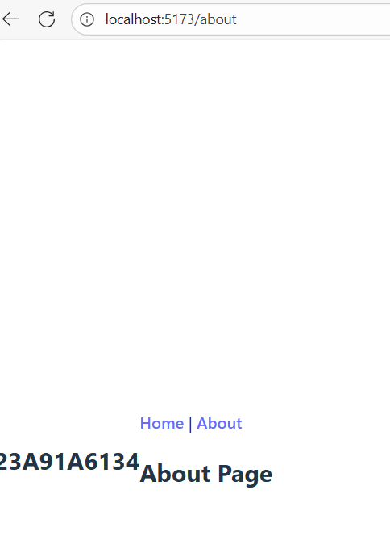
<head>
<meta charset="UTF-8" />
<link rel="icon" type="image/svg+xml" href="/vite.svg" />
<meta name="viewport" content="width=device-width, initial-scale=1.0" />
<title>my-app-week8a</title>
</head>
<h2>23a91a6134</h2>
<body>
<div id="root"></div>
<script type="module" src="/src/main.jsx"></script>
</body>
</html>

OUTPUT:

B) AIM: Write a program for updating the screen.

DESCRIPTION: This program demonstrates how to update the UI in real-time using React’s state management with the useState hook. User interactions, such as button clicks or input changes, trigger state updates, which automatically re-render the affected components on the screen. The program helps learners understand reactive programming, dynamic UI updates, and how React efficiently handles changes in the application state.

PROGRAM:

(Main.jsx)
import React, { useState, useEffect } from "react";

function Clock() {
const [time, setTime] = useState(new Date().toLocaleTimeString());

useEffect(() => {
const timer = setInterval(() => { setTime(new Date().toLocaleTimeString());
}, 1000);

return () => clearInterval(timer);
}, []);

return <h2><br></br>Current Time: {time}</h2>;
}

export default Clock;

(Main.jsx)
import { StrictMode } from 'react'
import { createRoot } from 'react-dom/client' import './index.css'
import App from './App.jsx'

createRoot(document.getElementById('root')).render(
<StrictMode>
<App />
</StrictMode>,
)

(Index.html)
<!doctype html>

<html lang="en">
<head>
<meta charset="UTF-8" />
<link rel="icon" type="image/svg+xml" href="/vite.svg" />
<meta name="viewport" content="width=device-width, initial-scale=1.0" />
<title>my-app-week8b</title>

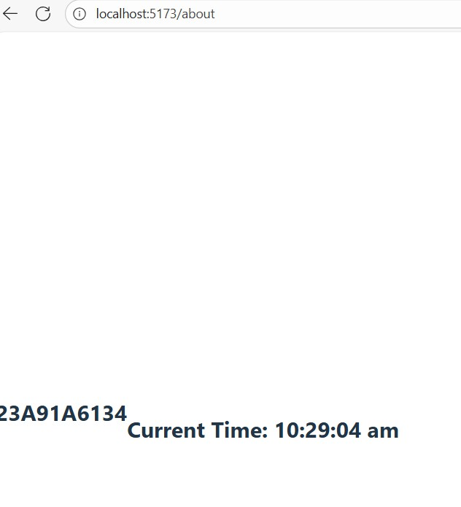
</head>
<body>
<h2>23a91a6134</h2><br>
<div id="root"></div>
<script type="module" src="/src/main.jsx"></script>
</body>
</html>

OUTPUT:

